Task 6

1. Chat GPT

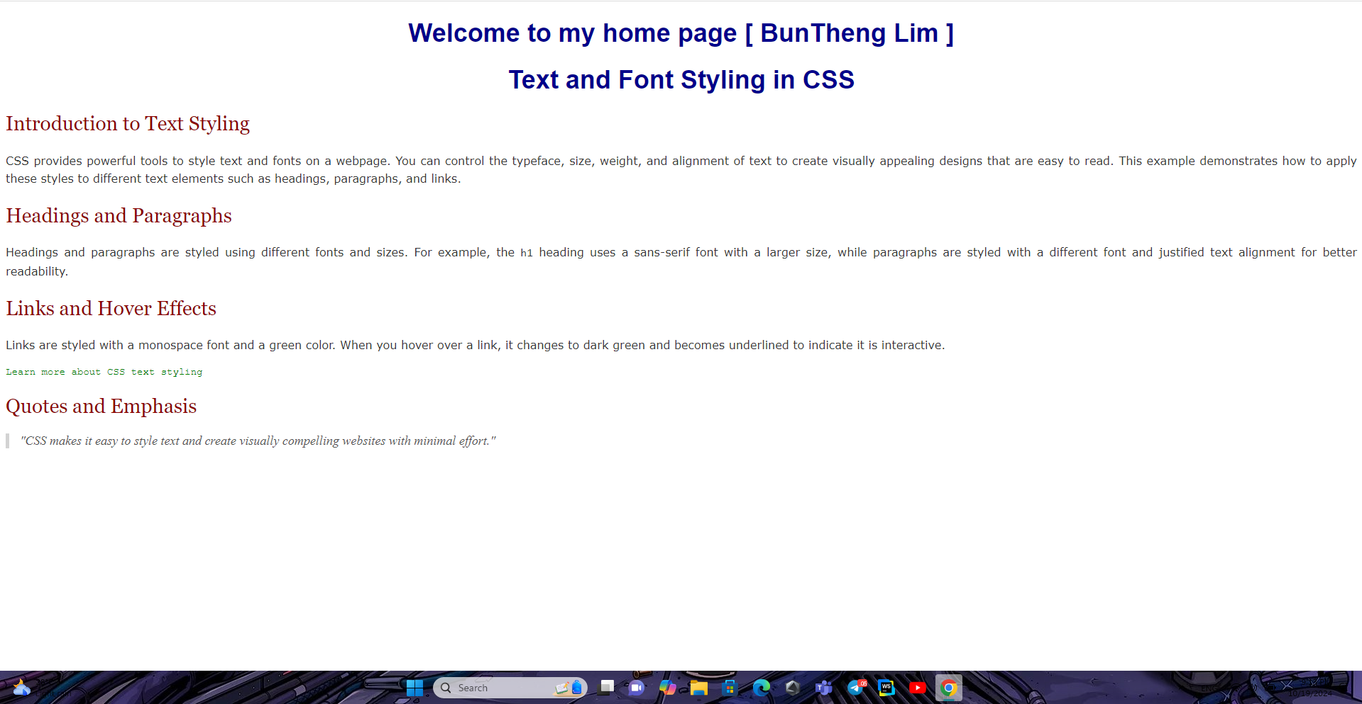

2. Gemini

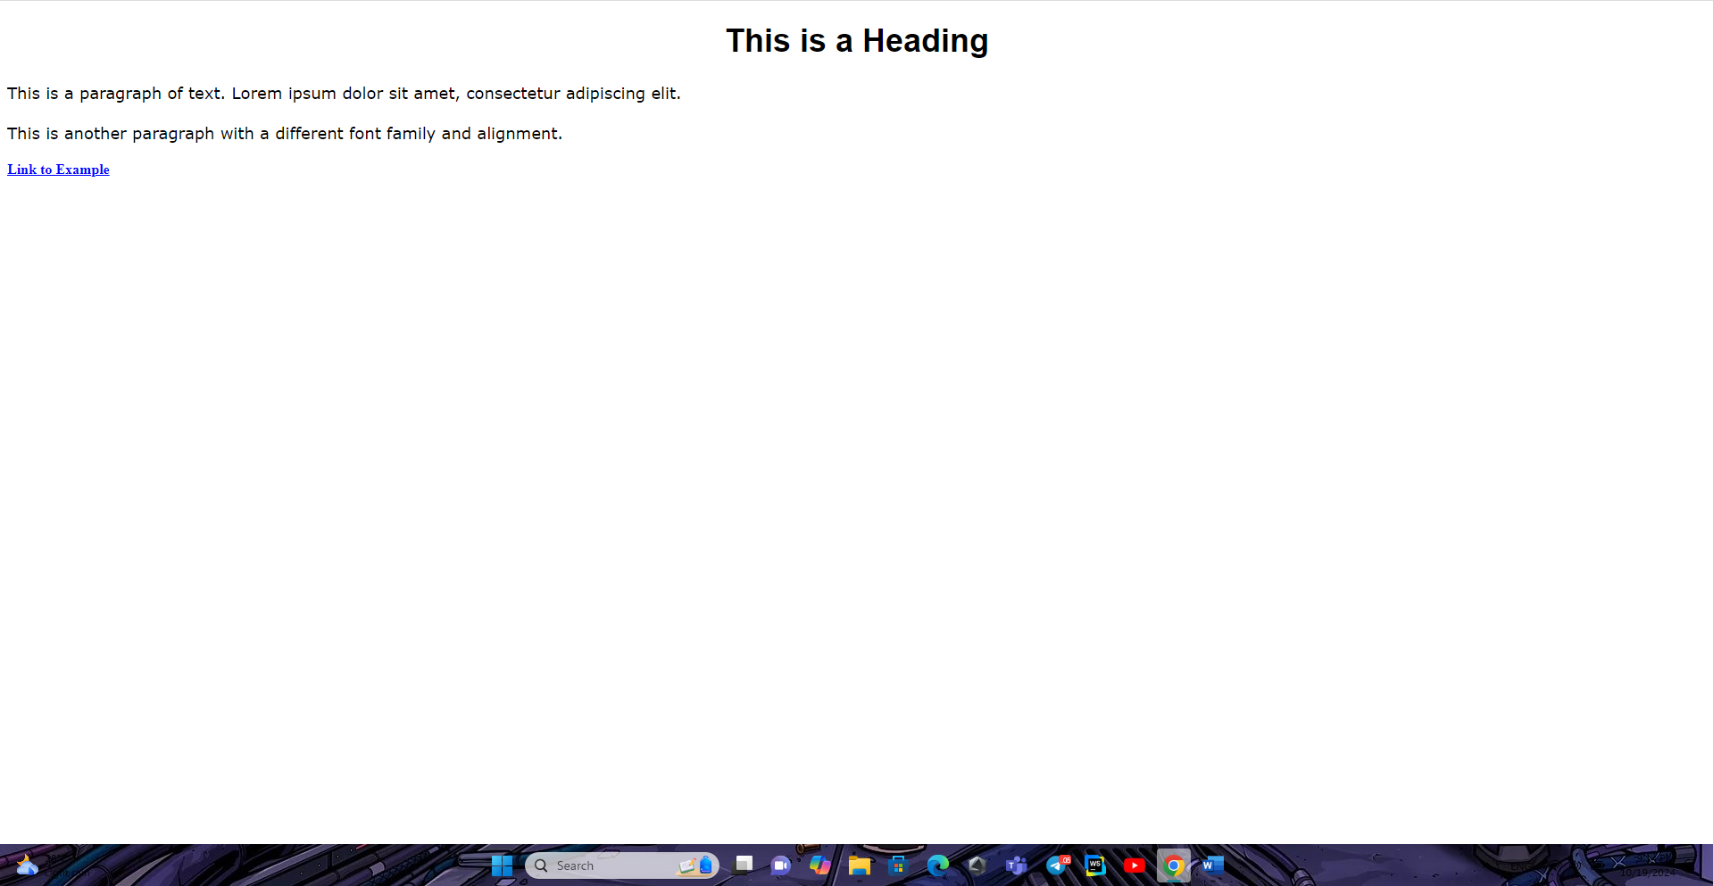

Result isn’t the same. Chat GPT is have follow the prompt but Gemini doesn’t have paragraph